1.

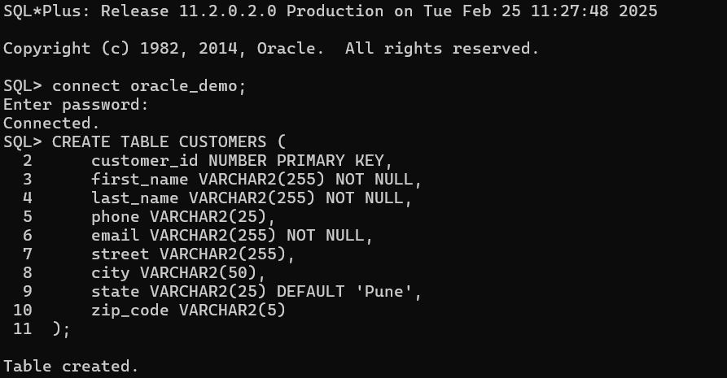

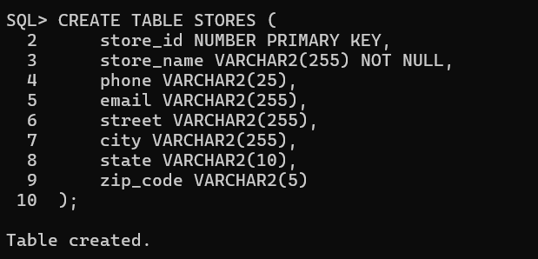

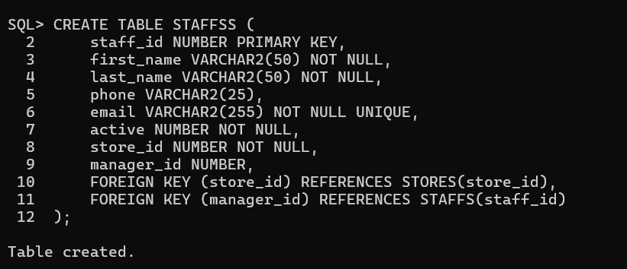

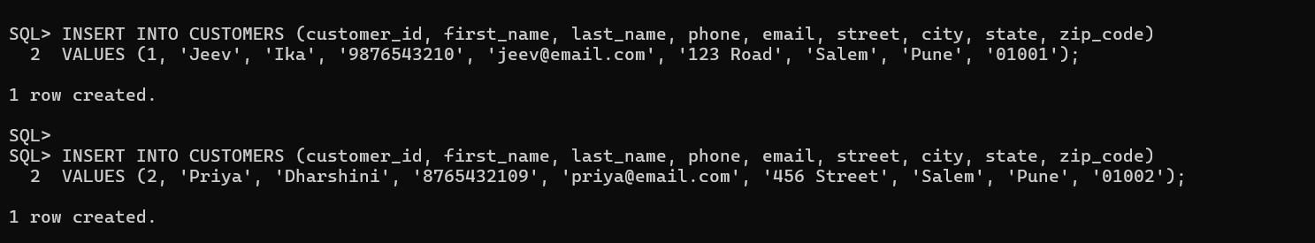

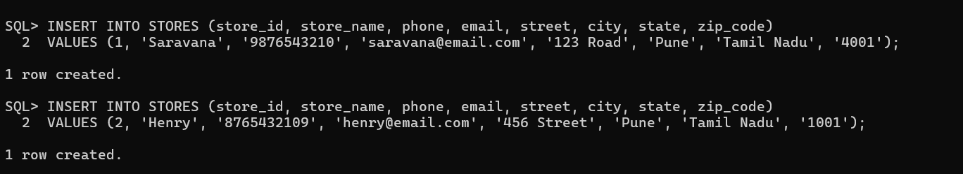

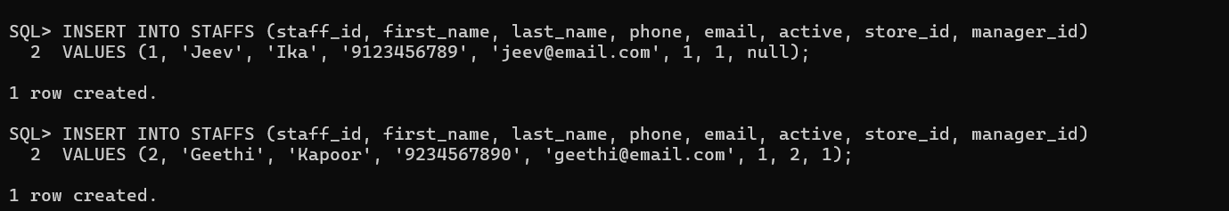

2.

1.

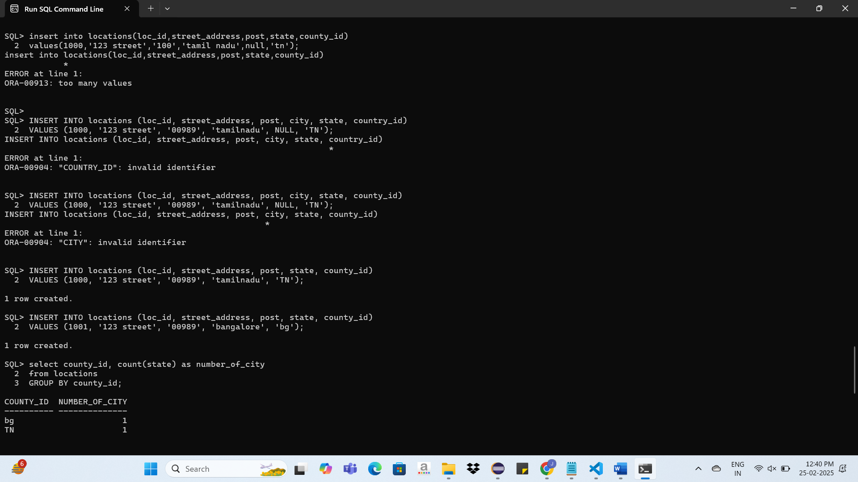

2.

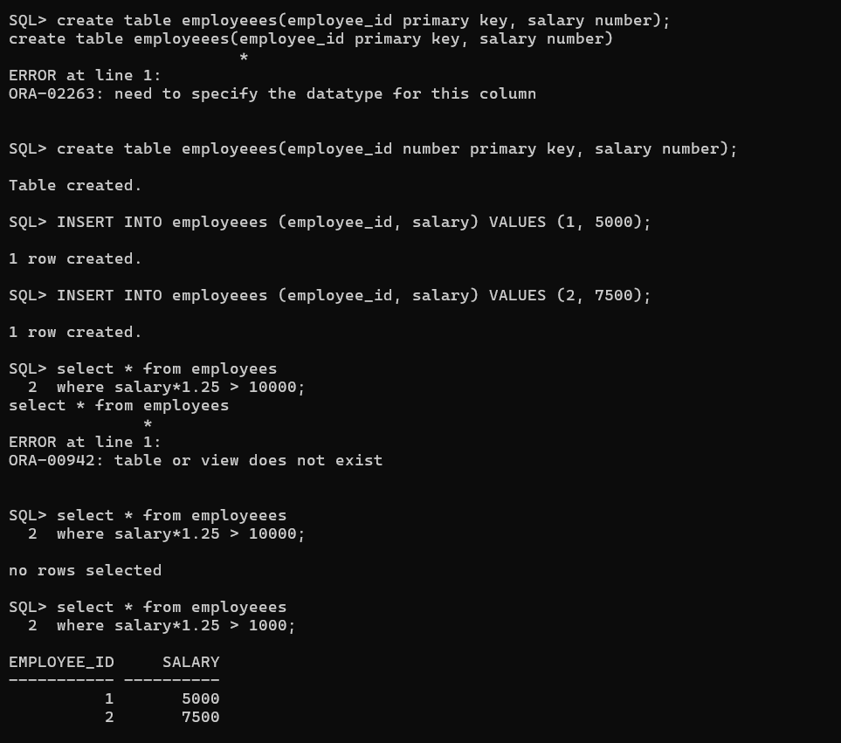

4.

SELECT *FROM employees

WHERE commission_pct IS NULL

AND salary BETWEEN 5000 AND 10000

AND department_id NOT IN (50, 80);

5.

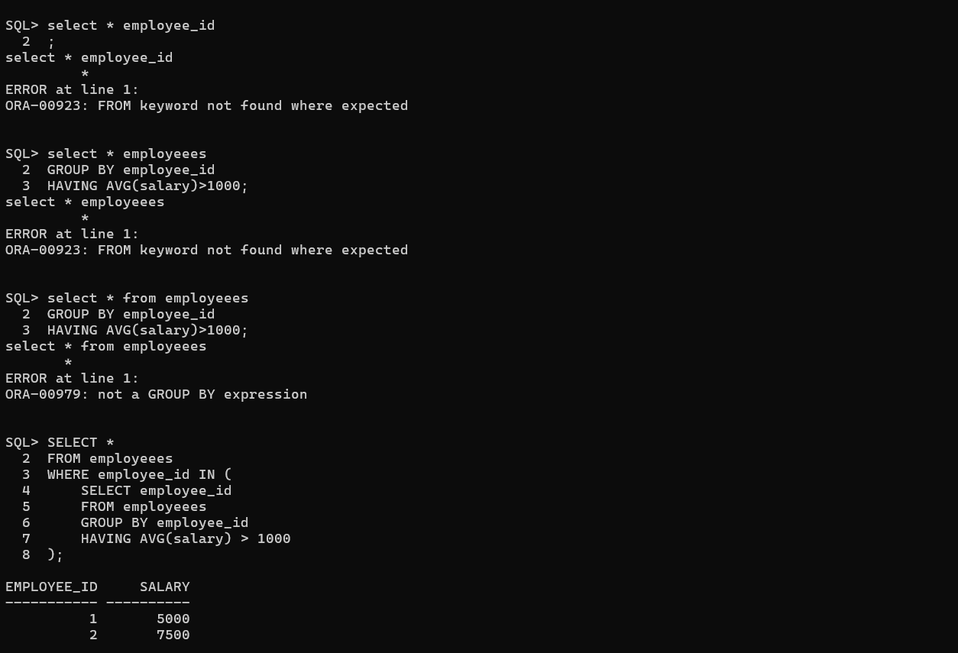

3.

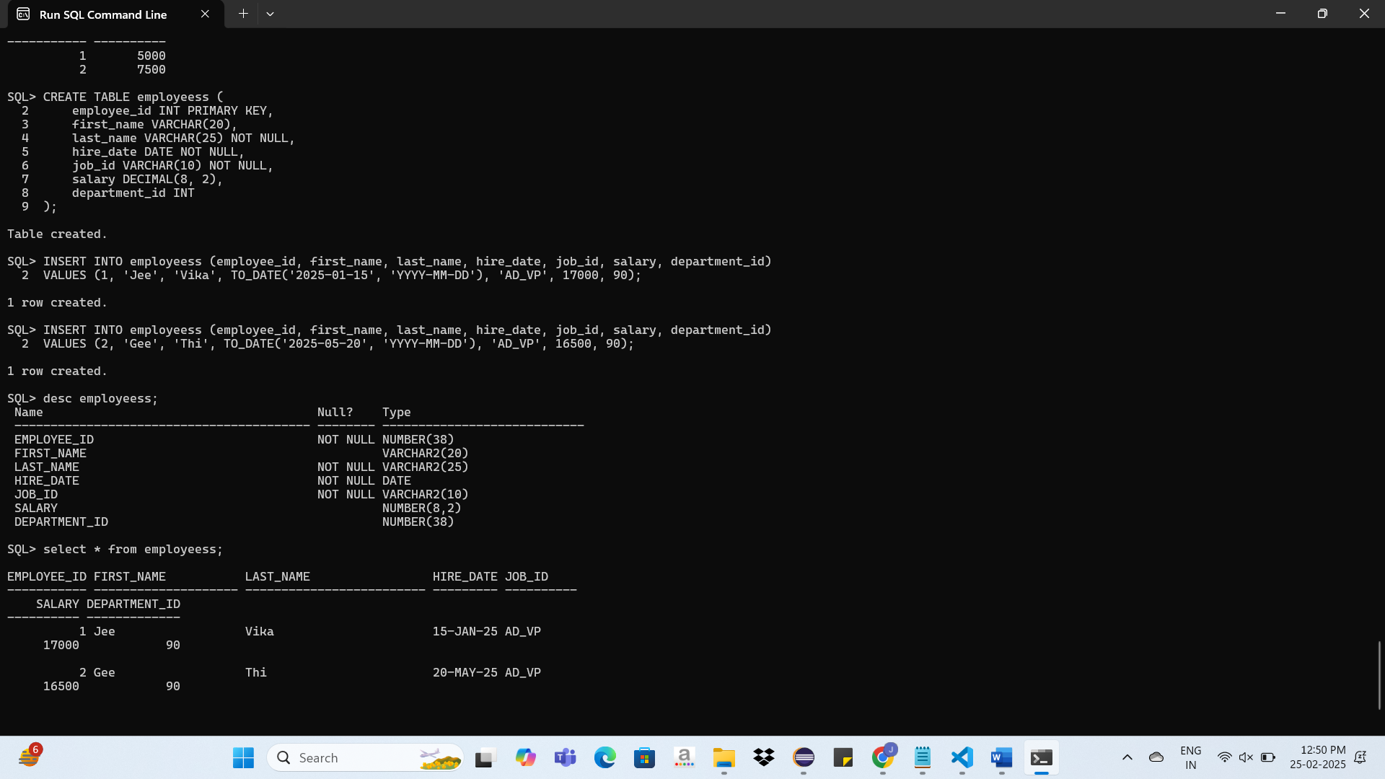

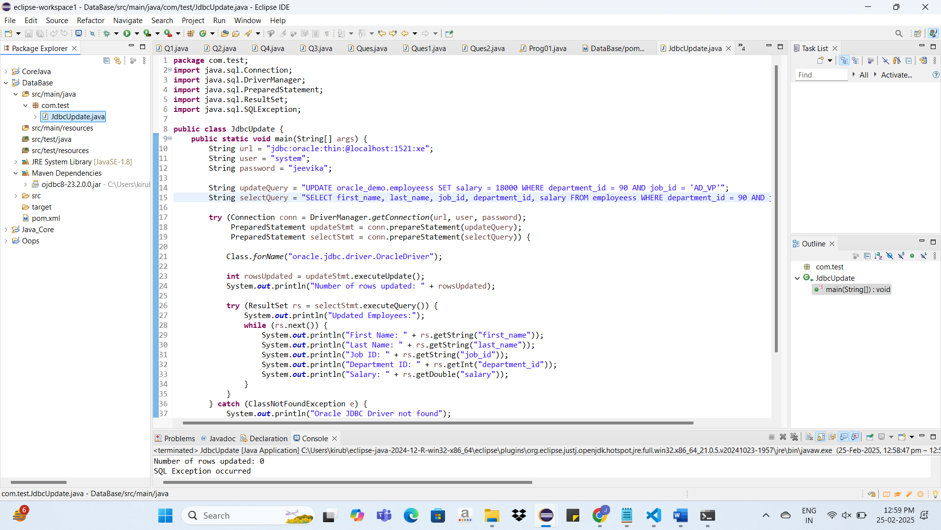

**package** com.test;

**import** java.sql.Connection;

**public** **class** JdbcUpdate {

**public** **static** **void** main(String[] args) {

String url = "jdbc:oracle:thin:@localhost:1521:xe";

String user = "system";

String password = "jeevika";

String updateQuery = "UPDATE oracle_demo.employeess SET salary = 18000 WHERE department_id = 90 AND job_id = 'AD_VP'";

String selectQuery = "SELECT first_name, last_name, job_id, department_id, salary FROM employeess WHERE department_id = 90 AND job_id = 'AD_VP'";

**try** (Connection conn = DriverManager.*getConnection*(url, user, password);

PreparedStatement updateStmt = conn.prepareStatement(updateQuery);

PreparedStatement selectStmt = conn.prepareStatement(selectQuery)) {

Class.*forName*("oracle.jdbc.driver.OracleDriver");

**int** rowsUpdated = updateStmt.executeUpdate();

System.***out***.println("Number of rows updated: " + rowsUpdated);

**try** (ResultSet rs = selectStmt.executeQuery()) {

System.***out***.println("Updated Employees:");

**while** (rs.next()) {

System.***out***.println("First Name: " + rs.getString("first_name"));

System.***out***.println("Last Name: " + rs.getString("last_name"));

System.***out***.println("Job ID: " + rs.getString("job_id"));

System.***out***.println("Department ID: " + rs.getInt("department_id"));

System.***out***.println("Salary: " + rs.getDouble("salary"));

}

}

} **catch** (ClassNotFoundException e) {

System.***out***.println("Oracle JDBC Driver not found");

e.printStackTrace();

} **catch** (SQLException e) {

System.***out***.println("SQL Exception occurred");

e.printStackTrace();

}

}

}